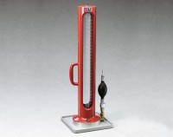 | Volumeasure  Code: 29-4522  Product Group: Volumeasure  1/20 cu. ft. (1,596 ml) capacity.

Standards
ASTM D2167, AASHTO T205

Spares/Consumables
 | Actuator Bulb Assembly  Code: 29-4522/13
Balloons
Code: 29-4522/10
Graduated Cylinder and Gasket Set
Code: 29-4522/11

