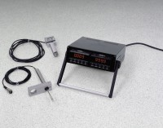 | 2 Channel Digital Readout, English  Code: 27-1108/01  Product Group: Digital Load and Displacement Readout, Versa-Loader, Digital Tritest 50 Load Frame  Transducers to be ordered separately. English units.

Further Information
220vAC, 50/60 Hz, 1ø.

