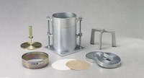 | 5 Lb. Annular Surcharge Weight ASTM.  Code: 24-9245  Product Group: Surcharge Weights, ASTM/AASHTO CBR mould and accessories

Specification
Construction | Machined steel.
Finish | Plated.

