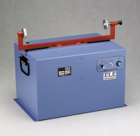 | Sand Equivalent Shaker  Code: 24-4949/02  Product Group: Sand Equivalent Shaker

Standards
ASTM D2419, AASHTO T176, CA 217, CA 229

Further Information
110vAC, 50/60 Hz, 1ø.

Specification
Motor | 1.9 Amp synchronized; 1/12 hp.
Cylinder Holder | Spring-loaded.
Shaking Mechanism | 8â (203 mm) stroke; 175 strokes/minute (+/- 2  strokes).
Timing Circuit | Built-in; 45 seconds, 10 minute and continuous run.
Dimensions | 19.5â w. x 14 â d. x 17â h. (495 x 35 6 x 432 mm) with holder.
Weight | Net 50 lbs. (23 kg).

Spares/Consumables
 | Sand Equivalent Cylinder  Code: 24-4917/10

