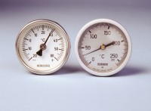 | Portable Thermometer +50 - +250°CPortable Thermometer +50 - +250°CPortable Thermometer +50 - +250°CP  Code: 82-5243  Product Group: Portable Dial-type Thermometers  64 mm diameter dial with a 650 mm long stem.

Further Information
**NOT AVAILABLE FOR SALE IN THE USA**

