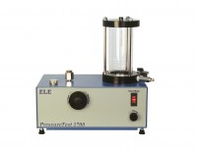 | Pressure Test 1700 Oil/Water Constant Pressure System 0 to 1700Kpa 220-240V 50/60Hz 1Ph.  Code: 26-1800/01  Product Group: Oil/Water Constant Pressure System, Air/Water Pressure Systems - up to 1000 kPa  • 0 to 1700 kPa (250 lbf/in²) fully variable  • Continuous constant pressure control  • One litre capacity  The ELE oil/water constant pressure system , PressureTest 1700, is extemely versatile and can be used in conjunction of with a wide range of test equipment. The unit provides continuous variable pressure up to 1700 kPa. Pressure is increased or decreased simply by turning a control wheel.  The apparatus is supplied without a gauge for those customers who have suitable pressure monitoring equipment. A digital pressure gauge is offered as an accessory. The machine features a clear hydraulic/water interface reservoir and up to one litre capacity of water is available under pressure.• 0 to 1700 kPa (250 lbf/in²) fully variable.

Further Information
Dimensions (without gauge) 240 x 400 x 500 mm (l x w x h).

Spares/Consumables
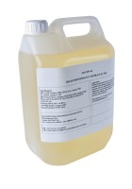 | Oil 5 Litres T46  Code: 26-1805

