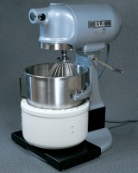 | Isomantle Electric Heater  Code: 45-5580/01  Product Group: Sample Mixers, Mixing, Sample Mixers  For use with 23-6191 Bench Mounting Mixer.

Standards
EN 12697-35

Further Information
**NOT AVAILABLE FOR SALE IN THE USA**

