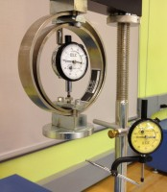 | Unconfined Compression Assembly Only  Code: 25-3999  Product Group: Versa-Loader  Includes: Platens. Proving Ring and Indicator not included, order separately

Standards
ASTM D2166, AASHTO T208

Spares/Consumables
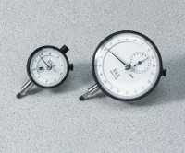 | Dial Indicator - 1.0" Range  Code: 88-4100

