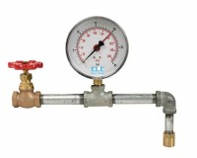 | Wet Washing Spray Attachment  Code: 79-7040  Product Group: Wet Washing Spray Attachment

Standards
ASTM C115, ASTM C430

Specification
Spray Nozzle | Machined brass.
Gauge | 30 psi (207 kPa) capacity.
Fittings | Standard pipe.
Weight | Net 11 lbs. (5 kg).

