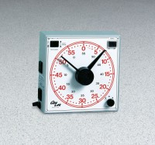 | Universal Time Switch  Code: 88-4310/02  Product Group: Universal Time Switches  60 minute range. 115vAC, 60 Hz, 1ø.

Specification
Load Capacity | Up to 750 watts (6 amps).
Time Range | 60 mins. x 1 sec.
Dial Face | 8â (203 mm) diam.
Outlets | One makes or breaks circuit after selected time interval; other automatically breaks  circuit at preset interval.
Controls | On/off switch; outlet switch; volume knob  for buzzer.
Construction | Steel case with handles.
Overall Dimensions | 8-1/2â w. x 2-1/4â d. x 8-1/2â h. (21 6 x 57 x 21 6 mm).
Weight | Net 3 lbs. (1.5 kg).

