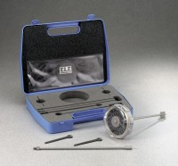 | Hand Vane Tester  Code: 26-3346  Product Group: Hand Vane Tester  • Direct-reading scale with max-reading pointer.  • Provides quick and accurate shear strength values of cohesive soils.  • Lightweight carrying case for easy transport to the field.  The Hand Vane Tester is an accurate and portable instrument used for the determination of in-situ shear strength of cohesive soils, either on-site or on undisturbed or remoulded samples in the laboratory.  The instrument consists of a torque head with a direct-reading scale which is turned by hand. A non-return type pointer retains the test reading. A 19 mm (0.75") diameter vane and 300 mm (11.8") extension rod is supplied as standard.

Standards
ASTM D2573, ASTM D4648

Further Information
Includes 19 mm (0.75") vane, extension rod and carrying case.

