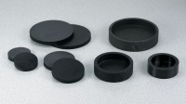 | Cylinder Capping Set  Code: 3000/02  Product Group: Cylinder Capping Set

Standards
ASTM C31, ASTM C192, ASTM C617, AASHTO T231, ASTM T126

Further Information
110vAC, 50/60 Hz, 1ø. 1,250 Watts.

