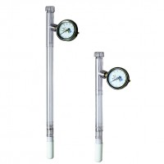 | Insertion Tool  Code: 514-030  Product Group: Tensiometers  To provide clearance hole and maintain hole diameter for tensiometers.

Further Information
1370 mm long.

