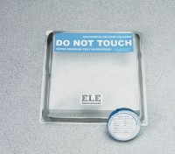 | Vapor Emission Test Kit  Code: 35-3968  Product Group: Vapor Emission Test Kit  Pack of 12.

Standards
ASTM E1907, F 1869

Specification
Absorbant | Anhydrous calcium chloride.
Dome | Clear plastic with butyl rubber gasket.
Weight | Net 5 oz. (12 0 g).

