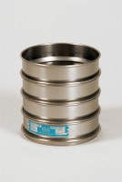 | 300mm Dia BS Sieve 22.4mm Perforated Plate.  Code: 79-2600  Product Group: 300mm Diameter BS Sieves, 300mm Diameter BS Sieves, 300mm Diameter BS Sieves

Standards
BS 410, ISO 3310

Further Information
**NOT AVAILABLE FOR SALE IN THE USA**

