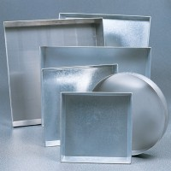 | Sample Tray - 306 x 306 x 38 mm  Code: 81-4020  Product Group: Sample Trays

Further Information
**NOT AVAILABLE FOR SALE IN THE USA**

