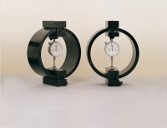 | Clamped Boss Load Ring - 10.0 kN  Code: 78-0460  Product Group: Clamped Boss Load Rings, Digital Tritest 50 Load Frame, Proving Rings, Force measurement

Specification
Capacity: kN, kgf, lbf | 10.0, 1000, 2250
Typical Design sensitivity: N/div, kgf/div, lbf/div | 7.7, 0.77, 1.73
Overall height mm | 248
Approx weight kg | 4.6
Capacity | 10 kN
Value of CBR | 8% to 40%
Capacity - lbf | 2,250
Capacity - kN | 10
Capacity - kgf | 1,000
Typical Design Sensitivity - lbf/div | 1.73
Typical Design Sensitivity - kN/div | 7.7
Typical Design Sensitivity - Kgf/div | 0.77
Overall Height | 9.76” (248 mm)
Approx Weight | 10.1 lbs.(4.6 kg)

Spares/Consumables
 | Spare Dial Indicator for Load Rings  Code: 78-5461

