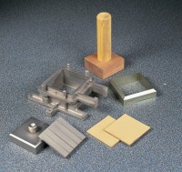 | Specimen Extrusion Tool 2.5 Inch Diameter.  Code: 26-2221  Product Group: Shear Box Assemblies, Shear Box Assemblies

Standards
ASTM D3080, AASHTO T236

Spares/Consumables
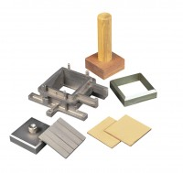 | Specimen Extrusion Tool 60 mm sq.  Code: 26-2189

