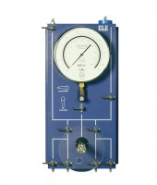 | Universal Pump and Pressure Indicating Panel 1700Kpa.  Code: 26-1880  Product Group: Modular Pressure Panel System  This is the main pressure display in the system for monitoring various pressures and also provides fine control of the pressure within the system using the rotary hand pump. The unit is fitted with a dual calibrated 250 mm diamter pressure gauge, four inlet/outlet no-volume change valves, screw controlled rotary hand pump, water reservoir and isolating valves. The unit is housed in a hinged case for wall or bench mounting. By using an isolating valve the panel may be used to monitor cell or back pressure. 1700 kPa and 250 lbf/in2.

Spares/Consumables
 | Pressure Gauge 1700Kpa (250Psi) 250mm Diameter.  Code: 26-1865/10

