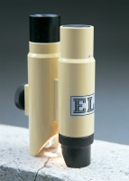 | Crack Detection Microscope Magnification X 40 Measuring Range of 4mm In 0.02mm Divisions  Code: 35-2505  Product Group: Crack Detection, Crack Detection Microscope  Specifically designed for measuring crack width in concrete, this high definition microscope operates via an adjustable light source provided by high power batteries.  Supplied in a pocket sized carrying case.

Specification
Dimensions (l x w x h) | 40 x 90 x 150 mm (in case)
Magnification | x 40
Measuring range | 4 mm, 0.02 mm divs
Weight | 550 g
Dimensions (l x w x h) | 40 x 90 x 150 mm (in case)
Magnification | x 40
Measuring range | 4 mm, 0.02 mm divs
Weight | 550 g
Magnification | X 35 .
Measuring Range | 4 mm.
Divisions | 0.02 mm.
Dimensions | 1.5â x 3.5â x 6â (40 x 90 x 15 0 mm) in case.
Weight | Net 19.4 oz. (55 0 g).

