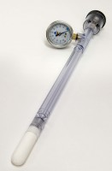 | Jet Fill Tensiometer 1220 mm  Code: 514-041  Product Group: Tensiometers  1220mm Long

Further Information
Requires Part No 514-034

