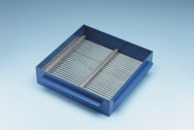 | Grid Sieve 20mm Slot Width for EN Aggregate Flakiness Test.  Code: 42-0320  Product Group: Grid Sieves  20mm

Standards
EN 933-3

Further Information
**NOT AVAILABLE FOR SALE IN THE USA**
Passing Size - 40 mm Retained Size - 31.5 mm

