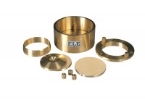 | 50mm Dia Upper and Lower Porous Stones for Use on EL25-0455 Series Cell.  Code: 25-0455/13  Product Group: High pressure application consolidation cells and accessories, Fixed Ring Consolidation

