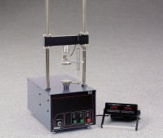 | Unconfined Compression Test Digital Readout Set, English 220 vAC  Code: 27-1121/01  Product Group: Versa-Loader  Includes: 2-channel digital readout, 500 lb. capacity S-type load cell, axial strain transducer with 2” range, platens and mounting hardware.

Standards
ASTM D2166, AASHTO T208

Further Information
220vAC, 50/60 Hz, 1ø.

