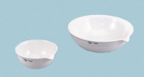 | Evaporating Dish - 385 ml Capacity  Code: 88-6714  Product Group: Evaporating Dishes  145 mm diam.; 385 ml capacity.

