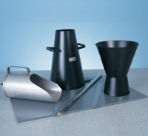 | Slump Cone  Code: 34-0110  Product Group: Slump Cones, Slump Test  Complies with EN 12350-2, ASTM C143 and AASHTO T119

Standards
ASTM C143, ASTM C192, AASHTO T23, AASHTO T119, ASTM T126

Specification
Construction | Seamless, heavy-gauge spun steel; 0.45" (1.1 mm) min. Thickness.
Finish | Plated for rust and corrosion resistance.
Dimensions | 100 mm top diam. X 200 mm bottom diam. (without foot pieces) x 300 mm h.
Weights | Net 5.5 lbs (2.5kg)

