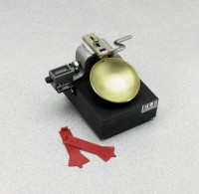 | Liquid Limit Set  Code: 2800E  Product Group: ASTM Liquid Limit Set  Set includes:  1 Liquid Limit Device with ASTM Grooving Tools (24-0435).  1 Graduated Cylinder 100 ml (88-6007).  1 Mixing Dish (88-6712).  2 Doz. Moisture Content Cans (88-7002).  1 Flexible Spatula (88-7500).

Standards
ASTM D4318

