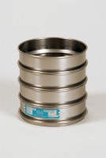 | 12in Dia Lid ASTM.  Code: 79-6150  Product Group: Sieve Lids and Receivers ASTM, U.S Standard Testing Sieves, 12" Diameter ASTM Sieves, 12" Diameter ASTM Sieves, 12" Diameter ASTM Sieves

Standards
ASTM E11

