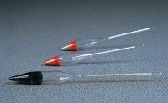 | Soil Hydrometer Type 151H ASTM D422 Graduated 0.995 to 1.038 Specific Gravity.  Code: 24-4650  Product Group: ASTM Soil Hydrometers, Soil Hydrometers  Graduated 0.0995 to 1.038 g/ml.

Standards
ASTM D422, ASTM E100, AASHTO T88

Specification
Construction | Molded, seamless.
Scale | Bouyoucos; double scale.
Calibration | At 68Â°F.
Weight | Net 4 oz. (113 g).

