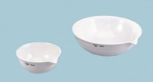 | Evaporating Dish - 250 ml Capacity  Code: 88-6712  Product Group: Evaporating Dishes, Bitumen Extraction Test  250 ml

Specification
Construction | Porcelain; with lip.

