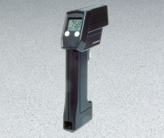 | Pistol-Grip Infrared Thermometer  Code: 88-4400  Product Group: Pistol Grip Infrared Thermometers

Specification
Range | -33Â°C to +500Â°C.
Accuracy | Â±2% or 2Â°C whichever is greater
Repeatability | Â±1.0% of reading or Â±1Â°C, whichever is greater
Response Time | 500 mSec.
Spectral Response | 8 - 14 Âµm
Display Resolution | 0.1Â°C (4 Digit LCD)
Emissitivity Value | Pre-set 0.95.
Power | 2 x 1.5V AAA alkaline batteries
Dimensions | 6.9â x 1.5â x 3.1â (175 x 39 x 79 mm).
Weight | 6.35 oz. (180 g).

