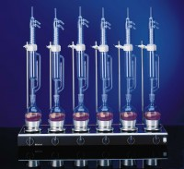 | Basic 6-Place Soxhlet Extraction System Less Glassware & Connections 220-240V 50/60Hz 1Ph.  Code: 525-402/01  Product Group: Soxhlet apparatus  The soxhlet apparatus is ued for the continuous extraction of fats and oils from solid material using an organic solvent such as petroleum ether. In a practical agricultural context the method is usually applied to the determination of "oil content" in agricultural produce such as sunflower and other oil seeds.  The material to be extracted is usually placed in a porous paper thimble and continuously condensing solvent allowed to perculate through it before returning to the boiling vessel either continuously or intermittently. The solvent can then be evaporated off to leave the fat.  A 4 place and 6 place system is available. Each heating unit has individual hotplates of 85 mm diameter with stepless heating control so that the temperature of each hotplate can be operated individually. The heating unit has a lacquered sheet steel casing with an enamelled top plate. The basic extraction system is supplied complete with top moulds, air bath inserts support rods, 600 x 12 mm and a connection cable.

