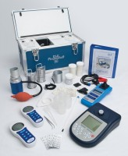 | Paqualab System 50 for Analysis of Drinking Water to Ec Standard Categories 1 & 2.  Code: 418-160  Product Group: Paqualab Standard Systems  Comprising the ELE Paqualab incubator 50, pH/temperature/mV meter, conductivity/temperature meter, turbidity meter, 0 - 50 NTU, ELE Paqualab photometer, and consumables for 200 tests on faecal or total coliforms, chlorine, ammonia, nitrates and nitrites.

Further Information
Overall dimensions 475 x 230 x 275 mm.

Spares/Consumables
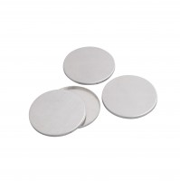 | Aluminium Petri Dishes Pack of 25.  Code: 422-560
 | Coliform Starter Pack. Sufficient for 200 Tests  Code: 422-010
Filtration Unit Al Construction Complete with Sampling Cup.
Code: 420-450
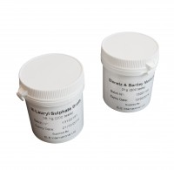 | Membrane Lauryl Sulphate Medium 38.1 Gram Pack. Sufficient for 200 Tests.  Code: 422-110
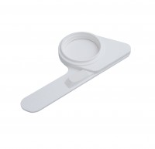 | Pad Dispenser.  Code: 422-515
Sterile Filter Membranes and ABSorbent Pads. Pack of 200.
Code: 422-508

