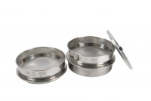 | 200 mm Diameter Lid  Code: 79-0010  Product Group: Sieve Lids and Receivers ISO and BS, 200mm Diameter BS Sieves, 200mm Diameter BS Sieves, 200mm Diameter BS Sieves

Standards
BS 410, ISO 3310

Further Information
**NOT AVAILABLE FOR SALE IN THE USA**

