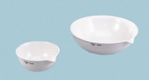 | Evaporating Dish - 765 ml Capacity  Code: 88-6716  Product Group: Evaporating Dishes  185 mm diam.; 185 ml capacity.

