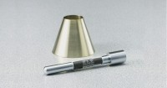 | Sand Absorption Cone and Tamper  Code: 42-1725  Product Group: Sand Absorption Cone and Tamper

Standards
ASTM C128, AASHTO T84

Specification
Mold | Brass; 40 mm top diam. x 90 mm base diam. x 75 mm h.
Tamper | Steel; 1â diam. working face x 6-5/8â l. (25 .4 x 168 mm);  12 oz.(34 0 g) weight.
Weight | Net 1 lb. (453 g).

