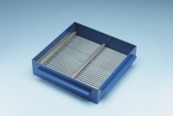 | Grid Sieve 25mm Slot Width for EN Aggregate Flakiness Test.  Code: 42-0322  Product Group: Grid Sieves  25mm

Standards
EN 933-3

Further Information
**NOT AVAILABLE FOR SALE IN THE USA**
Passing Size - 50 mm Retained Size - 40 mm

