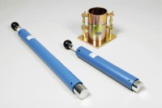 | Standard Compaction Rammer 2.5Kg BS1377-1975  Code: 24-9002  Product Group: BS/EN compaction test 2.5kg  50mm diameter with 300mm drop, manufactured from corrosion protected steel.

Standards
BS 1377-4, BS 1924-2, EN 1997-2

Specification
Rammer | 50 mm dia, 2.5 kg
Drop | 300 mm
Guide Sleeve | Machined steel tubing with air pressure release holes
Finish | Corrosion resistant
Weight kg | 4.2

