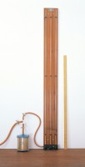 | Falling Head Permeability Cell.  Code: 25-0605  Product Group: Falling Head Apparatus

Specification
Cell | Plated seamless tube 100 mm diameter  x 130 mm height
Base | Porous plate with three tie rods
Top plate | Machined to accept smaller tubes
Weight kg | 3.4

