 | Coliform Starter Pack. Sufficient for 200 Tests  Code: 422-010  Product Group: Microbiological starter packs and consumables  Sufficient for 200 tests. Comprising 200 grid membranes and absorbent pads, one pad dispenser and 38.1 grmas membrane Lauryl Sulphate broth.

Spares/Consumables
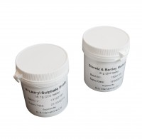 | Membrane Lauryl Sulphate Medium 38.1 Gram Pack. Sufficient for 200 Tests.  Code: 422-110
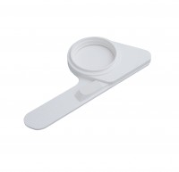 | Pad Dispenser.  Code: 422-515
Sterile Filter Membranes and ABSorbent Pads. Pack of 200.
Code: 422-508

