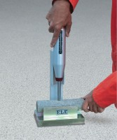 | NW Rock Cradle  Code: 77-0480  Product Group: NW Rock Cradle, Rock Classification Hammer

Specification
Construction | All metal; treated for rust resistance.
Core Size | NW size specimens.
Weight | Net 20 lbs. (9.1 kg).

