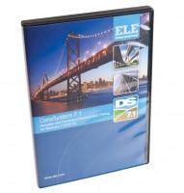 | DS7.1 CU/CD Triaxial Shear Strength Program for Windows 7, 32/64 bit  Code: 27-1762  Product Group: N/A  • Complete package for consolidated drained and consolidated undrained triaxial tests  This advanced package includes procedures for consolidated drained and consolidated undrained tests. Standard options are available for saturation, consolidation and shearing with automatic monitoring of the various parameters through transducers linked to the system. Load, strain, volume-change, pore-pressure, cell pressure and back pressure can all be monitored. Various prints and graphical plots are available to the engineer and include saturation data such as pore pressure build-up and B values, consolidation, volume change against time, shearing load versus strain with pore pressure monitoring.

