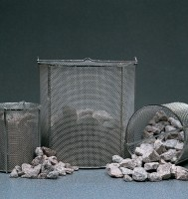 | Wire Basket - 150 μm wire mesh  Code: 81-4819  Product Group: Soundness of Aggregates, Wire Baskets

Further Information
**NOT AVAILABLE FOR SALE IN THE USA**

