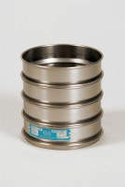 | 8in Dia Receiver.  Code: 79-5410  Product Group: Sieve Lids and Receivers ASTM, U.S Standard Testing Sieves, 8" Diameter ASTM Sieves, 8" Diameter ASTM Sieves, 8" Diameter ASTM Sieves

Standards
ASTM E11

