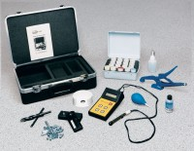 | Chloride Field Test System  Code: 35-2167  Product Group: Chloride Field Test System

Specification
Meter | Battery powered, high impedance electronic  meter with temperature compensation circuits and microprocessor for direct conversion to percent of chloride.
Electrode | Chloride combination type with externally mounted temperature sensor, cable and connectors.
Components | 12 jars (20 ml each) of extraction liquid, 5 jars of colored calibration liquid, 1 jar of wetting agent,  spray bottle, collection pan and blower, clamping pliers, drill bit and anchors, scales and carrying case.
Weight | Net 10 lbs. (5 kg).

