 | Engineer's Steel Rule  Code: 81-0805  Product Group: Miscellaneous Laboratory Hardware

Further Information
**NOT AVAILABLE FOR SALE IN THE USA**

Spares/Consumables
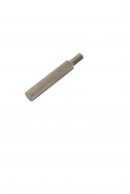 | Consistency Plunger  Code: 38-2010/10

