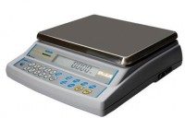 | Electronic Balance - 250 g x 0.1 mg  Code: 78-5335/01  Product Group: Electronic Balances

Further Information
**Not available for sale in the USA**

Specification
Capacity resolution | 250 g x 0.1 mg
Pan size | 100 mm dia
Mains and battery | No
Dimensions (l x w x h) | 470 x 185 x 280 mm
Weight | 12 kg

