 | Proving Ring, 2,000 lbs  Code: PR-20  Product Group: Additional Analog Proving Rings  (907 kg), 8.459" h.

Spares/Consumables
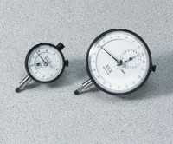 | Mechanical Dial Indicator - 0.2" Range  Code: 88-4000

