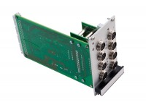 | 8-Channel Expansion Analog Input Module  Code: 27-1505  Product Group: Geotechnical Data Acquisition Unit (GDU)

