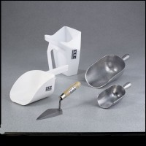 | Round Bottom Scoop 1/2 qt. Capacity  Code: 88-7300  Product Group: Round Bottom Scoops  1/2 qt. (0.473 liter) capacity. Aluminum.

Specification
Dimensions | 3-1/4â x 5â x 2â  (82 x 127 x 51 mm).

